Daily Tip 82 24/11/2003 11:37:00 AM
Generating graphs automatically for some procedures
There is a new feature available for some procedures in SAS 9 which will produce a graphic automatically for certain statistical procedures that are used. One such procedure is PROC LIFETEST. To get the graph you simply turn ODS GRAPHICS ON and then choose the graph required using the plots=(variable) option on proc lifetest.

Sample code
ods listing close ;
ods html file='lifetest.html' style=mystyle;
ods graphics on;
proc lifetest data=sasuser.fitness;
time age;
survival confband=all plots=(hwb);
run;
ods graphics off;
ods html close;

Graph produced
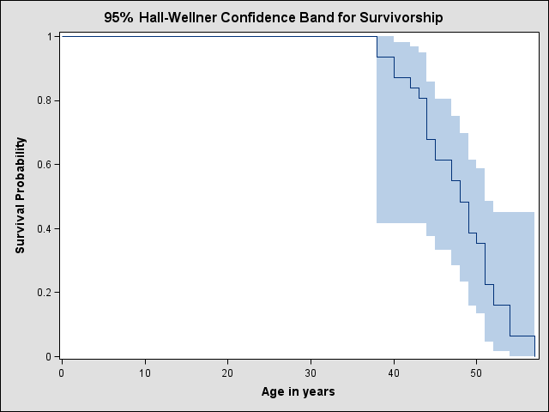Example tested under SAS 9.1, Windows XP by Phil Mason
Wood Street Consultants Ltd. tips@woodstreet.org.uk
www.woodstreet.org.uk
Instant Messengers … ICQ:27165944, AOL:philipamason, MSN: philipandrewmason@hotmail.com, Yahoo: philipandrewmasonb

